**HOME STAY RESERVATION web application SYSTEM**

MISHAL SHAKINA RAJAMANICKAM

Academic project I report submitted in FULFILMENT OF the requirEmentS FOR the **Executive Diploma in Information Technology**

**CEntre for continuing education (UMCCed)**

UNIVERSITY OF MALAYA

Kuala lumpur

**2022**

**UNIVERSITY OF MALAYA**

**ORIGINAL LITERARY WORK DECLARATION**

Name of Candidate: Mishal Shakina (I.C/Passport No: (950620-14-8102)

Matric No: UFH190045

Name of Degree: The Executive Diploma in Information Technology

Title of Project Paper/Research Report/Dissertation/Thesis (“this Work”):

Home Stay Reservation System

Field of Study: Information Technology

I do solemnly and sincerely declare that:

1. I am the sole author/writer of this Work;
2. This Work is original;
3. Any use of any work in which copyright exists was done by way of fair dealing and for permitted purposes and any excerpt or extract from, or reference to or reproduction of any copyright work has been disclosed expressly and sufficiently and the title of the Work and its authorship have been acknowledged in this Work;
4. I do not have any actual knowledge nor do I ought reasonably to know that the making of this work constitutes an infringement of any copyright work;
5. I hereby assign all and every right in the copyright to this Work to the University of Malaya (“UM”), who henceforth shall be owner of the copyright in this Work and that any reproduction or use in any form or by any means whatsoever is prohibited without the written consent of UM having been first had and obtained;
6. I am fully aware that if in the course of making this Work, I have infringed any copyright whether intentionally or otherwise, I may be subject to legal action or any other action as may be determined by UM.

Candidate’s Signature Date:

Subscribed and solemnly declared before,

Witness’s Signature Date:

Name:

Designation:

Abstract

The following paper is a project proposal for the development of a web-based home stay reservation system. The goal of the project is to automate the manual tasks associated with hotel reservations, such as reservation, billing, services management, records of all data and room management. The manual method of carrying out these responsibilities is neither efficient nor effective. One of the aims of this project is to reduce the need for paper work and save time while simultaneously improving the efficiency of the process. Additionally, the project intends to enable advanced online reservation as well as cancellation from any location at any time by staff. In addition to making the process of computing the customers' bills easier, this new system also be able to display the available rooms and allocate a room in accordance with the clients' specific requirements.

This project also has the goal of developing a system that will be able to store information about their customers and retrieve that information when it is requested. Also, the new system will make sure that it is safe and reliable. The suggested system has the goal of providing home stay with an interface that is one of a kind, cutting edge, and user friendly, which will change the way that people use the internet today.

Because of how busy the hotel manager is, he or she just does not have the time to sit down and physically manage all of the activities using paper. This application provides him with the capability and adaptability to handle the complete system from a single web location. The system lets the manager put up a list of rooms that are available.

The homestay reservation system enables guests to reserve rooms, add employees, and use a check-in/check-out process that includes a discount function, among other features. Consequently, this method enables the administrator to add or remove employee login privileges at their discretion. Users will have two unique login options as a result, enabling them to operate more effectively and hassle-free.

Table of Contents

ABSTRACT 3

CHAPTER 1: Introduction 5

1.1 Background 5

1.2 Problem statement 6

1.3 Objectives 8

1.4 Scope and Delimitation 9

CHAPTER 2: LITERATURE REVIEW 11

2.1 Existing System 16

2.2 Table of Comparison with Other System 18

CHAPTER 3: SYSTEM DESIGN 19

3.1 System Methodology 19

3.2 System Requirement 21

3.3 List of Facts and Assumptions 22

3.4 Performance Requirements. 22

3.5 Software Quality attributes 23

3.6 What contribution would the project made? 23

3.7 Specific requirements 23

3.8 Look and Feel Requirements 23

3.9 Software Product Feature 24

3.10 Usability and Humanity Requirements. 24

CHAPTER 4: DELIVERABLES AND TIMELINE 38

CHAPTER 5: CONCLUSION 39

REFERENCES 40

APPENDIX 42

# Introduction

## 

Systematic record management helps organizations be more efficient and effective, reduce administrative costs (both in terms of staff time and storage), support decision-making, be accountable, achieve business objectives and targets, provide continuity in the event of a disaster, comply with legal and regulatory requirements, and safeguard the interests of clients and employees.

Because of the information they hold, records are valuable. However, that information is only useful if it is accurately and legibly recorded in the first place, is maintained current, and is simple to find when needed.

Although records from hotels are not frequently discovered in archives, when they do, the information they offer is valuable to a range of researchers, including students, genealogists, and academics.

Due to manual recording systems, businesses like hotels, pension houses, apartments, and the like occasionally experience transaction delays. Form preparation and file retrieval also take a lot of time. Due to the problems previously highlighted, the proponent wants to replace the present system it is using with a web-based hotel room management information system.

## Background

Since the invention of the electronic computer, processing information and making decisions have become quite simple. In contrast to the manual method, which becomes tiresome and time-consuming as file size increases, data may now be saved on a computer in a significant amount of less space and retrieved within a short period of time. Although humans can also store, retrieve, and process data, the main distinction between computers and humans is that the former can consistently carry out millions of commands in a millisecond and save the results, while the latter requires a longer amount of time. A software programme known as a "Home stay reservation System" allows for computerized management of the entire hotel. The application keeps track of all of the everyday tasks carried out at the hotel, including client information, reservation information, adding new rooms, releasing old ones, etc. These tasks are all computerized, making management simple. Additionally, it generates filter results between specific dates for authorized users, saving time and easing the strain associated with the manual technique.

## Problem statement

Based The purpose of this study is to assess the Web Based Hotel Room Management Information System. It seeks the answers of the following questions:

1.) What are the difficulties encountered by the employees of the said Pension Haus in their present reservation system?

2.) What is the performance of the Manual Booking System of Hotels, Pension Houses and Apartments in terms of:

a.) Security;

b.) Accuracy;

c.) Speed;

d.) Record keeping?

3.) What is the extent of preference of Hotels, Pension Houses, and Apartments home stays to adopt an Automated Booking Record System Web Based Home stay Reservation Management Information System?

##### Problem definition

Managing hotel service is very complex, hence it involves the job of dealing with customers directly, purchases made by customers and room reservation. The manual hotel management is subdivided into sections with each section having specific tasks. These tasks interact operationally to achieve organizational objectives. The mode of interaction has characteristics of a typical manual system i.e. communication through verbal means, use of paper documents etc. These activities are autonomous and as a result redundancy may arise. They are also cumbersome and prone to error.

##### General Problem:

Manual entry consumes more time. It is difficult to maintain bulk of record in manual. Restrictions in the users. Not easy to prepare the daily reports. Lack of accuracy and error prone. Overall efficiency is less. Lot of paperwork. Non-secure. No perfect maintenance of report. No method to trace details. Human errors. The manual system is too slow. Searching is more time consuming.

**Specific problem:**

In that case, since the number of travelers increased, many places like Kuantan, Kedah they don’t have a reservation system to reserve the room. However, many hotels out there around Malaysia a proper system has been develop online for both customer and backend users as well. The following points are mainly current problem.

* Customers having little or no information about the hotels in their vicinity.
* A guest checking into a hotel room that is either too expensive or too unbefitting for his or her personality.
* Prolonged delay by the receptionist in retrieving certain information about any particular guest on demand.
* Possibility of fraud by the receptionist in not documenting officially information about some guests that checked into the home stay rooms.

##### Problem Justification

There’s a genuine need for an online reservation system. The manual system is prone to many problems like duplication of work which might arise in errors being made in room allocations. It also takes a lot of effort to get information such as total number of bookings made at a particular time or total sales made in a day. The world has become a global village it is crucial for a hotel aiming to attract many clients to have a system whereby clients can make reservations on the go, from whatever location in the country or outside the country. Majority of hotels in the country do not have a facility whereby a person can make a reservation from a remote location. The ones that have do so through intermediaries or agencies. In Malaysia more so during holidays, so many people prefer to spend their time in a distant location and therefore have to book accommodation at a hotel. But it is disheartening to travel so many kilometers only to find the room has been booked by several other people. Such cases arise when booking is done through agencies or the hotel uses manual systems, which are often inefficient. An Online Home Stay Reservation System will eliminate such instances which are likely to occur in a manual system especially when the job load is big which the case is during some seasons of the year. It’ll also improve efficiency in the hotel operations.

**Alternate Solution: -**

Web based Home Stay is best alternate solution of these problems. As it saves a lot of time, also an effective way to keep record of the home stay and from the financial point of view it also increases profit of owners because less staff required.

## Objectives

This study aims to provide the staffs, managers and especially the owner of Hotels, Pension Houses, and Apartments an effective, fast, and convenient way of recording the transactions of their customers. This will lead to the improvement of the current system they are using and for the betterment of the establishment. It will contribute to the success of the business and to gain the trust of their customers.

The goal of the current system is to develop a home stay reservation system to replace the computerized Hotel reservation

A web based solution will be delivered so that users the system with their favorite browser. By designing around a standardized language like asp.net the application will run on the most popular computer platforms connected to the internet will allow employees to more easily share information.

The Home Stay Reservation System Software is intended to provide a computer based system that will assist in managing in a guest. Many typical functions involved in operating a Home Stay will be automated through software to improve the operational workflow within a facility, for instance maintaining a guest rooms to be check in. in addition, tasks like processing payment and filter guests records will be available within the program to minimize the time that administrative staff must spend creating these documents.

This study also aims the following:

1.) To enable the staff and employees of Hotels, Pension Houses, and Apartments to have a fast processing of their booking system;

2.) To have a convenient way of entering customers data without any delay;

3.) To save their time and effort in listing manually the needed data;

4.) To retrieve data anytime;

5.) To have a more secure and private records or files;

6.) To have accurate details of data needed.

## Scope and Delimitation

The mission of this project is to facilitate easy management and administration of a Home Stay with capabilities to do Booking or reservations of the rooms, Cancellation of the rooms, creating of new user, Room service, Total billing etc. using the computerized web Home stay management’s Web. One can keep detailed records or info on an unlimited amount of customers. The web lets the user know which all rooms are available for occupancy at any point of time. This makes the booking considerably faster. And thus helps the Home Stay in better management and reduce a lot of paper work as well as manpower.  
Limitations.

* Inadequate IT infrastructure.
* Limited time duration
* Justification

This software is built up top meet need of a computerized “HOME STAY RESERVATION MANAGEMENT”. This is based on new techniques and based on new idea. This is totally different and beneficial for other to easily use and understand. This Web provides fresher processing of any query and make information up–to–date.

**Scope**

It may help collecting perfect management in details. In a very short time, the collection will be obvious, simple and sensible. It will help a person to know the management of passed year perfectly and vividly. It will be also reduced the cost of collecting the management & collection procedure will go on smoothly. Our project aims at Business process automation, i.e. we have tried to computerize various processes of Home Stay web application. In computer system the person has to fill the various forms & number of copies of the forms can be easily generated at a time. In web system, it is not necessary to create the manifest but we can directly print it, which saves our time. To assist the staff in capturing the effort spent on their respective working areas. To utilize resources in an efficient manner by increasing their productivity through automation. The system generates types of information that can be used for various purposes.

This study primarily focuses on delivering retailing business web application through the use of a web system that allows businesses to track services and strives to give an accurate and dependable process on every transaction, particularly in a reservation web application. The purpose of this study was to investigate how the use of technology in today's world influences our day-to-day lives. In order to ensure that our beneficiaries are equipped with accurate information, it is crucial that we conduct research comparing and contrasting the benefits of employing a manual system with those of the modern, computerized one.

**Delimitation**

Home Stay Reservation Web application manages all forms of homestay bookings. Its comprehensive hotel reservation, marketing & merchandising features let you regulate dynamic room, give discounts, provide varied prices and commissions, room size, reserving and cancelling, and preserving records.

# Literature review

The application of the Internet in the business world has become a major trend in practice and generated a hot stream of research in the recent literature. The Internet, as a collection of interconnected computer networks, provides free exchanging of information. Over 400 million of computers or more than 400,000 networks worldwide today are communicating with each other (Napier, Judd, Rivers, and Wagner, 2001). As such, the Internet has been becoming a powerful channel for business Marketing and communication (Palmer, 1999), and for new business opportunities – as it is often called as “e-business” or “e-commerce” today (Schneider & Perry, 2001). This new e-business or e-commerce virtual marketplace allows small companies competing with business giants by just having a better web presentation of their products/services. Under the same wave, online customers can enjoy a wider choice of products or services, more competitive prices, and being able to buy their favorite items/services from the sellers located thousands miles away. It provides communication between consumers and companies and through electronic data interchange (EDI), buyers and sellers can exchange standard business transactions such as invoices or purchase orders with remarkable ease. The hotel industry is certainly full aware of this trend and fully willing to contribute its share in this effort. In fact, the industry has realized that during those early forays into cyberspace, the industry didn’t view e-booking strategically (many hotels simply considered online room bookings at the time as a way to pick up additional business by selling distressed inventory through those online travel agencies), and handed over too much control of inventory and pricing to those third party online travel agencies. Now the industry is in the unenviable position of trying to take back the reins after early shopping patterns have been established. While the pressure to sell their inventory rooms online will be continuing, the industry has developed its new online strategy striving to get a better grip on this emerging marketing channel. (http://www.iima.org/CIIMA/CIIMA%20V3%20N1%201%20Yang.pdf)

Online system has evolved to be a cornerstone in support of computer software users of all kinds. It is an electronic interactive system that delivers information to users via telephone lines to personal computers (PCs) or via cables to terminals. Such a service provides information, usually in text form, about news, education, business, entertainment, shopping, and more. Some also provide message services and graphic and audio information.

Online hotel reservations are becoming a very popular method for booking hotel rooms. Travelers can book rooms from home by using online security to protect their privacy and financial information and by using several online travel agents to compare prices and facilities at different hotels. People can book directly on an individual hotel’s website. An increasing number of hotels are building their own websites to allow them to market their hotels directly to consumers. Non-franchise chain hotels require a “booking engine” application to be attached to their website to permit people to book rooms in real time. One advantage of booking with the hotel directly is the use of the hotel’s full cancellation policy as well as not needing a deposit in most situations. (http://en.wikipedia.org/wiki/Online_hotel_reservations)

Online Hotel Reservation Software (OHRS) is an easy to use arrangement that enables agents and guests to reserve rooms directly via the internet once they have confirmed availability of rooms in accordance with the itinerary.OHRS is an efficient and brilliant software, yet it is easy and uncomplicated to use. OHRS grants complete authority and power on hotel or motel room booking over the internet. This entails that one can accumulate all guest payments; enter own room descriptions, facilities, rates and allocations into the Reservation System. OHRS also allows to confirm accommodation in real-time at hotel’s web site and close the sale without more ado. (http://www.dotcomtechno.com/ohrm.html) There are several benefits of OHRS. It makes the reservation process computerized and thus helps one to undertake a large amount of transactions at a low cost. It lets the hotel in charge of over margins and pricing strategy. It enables one to check available inventory and complete an online booking form making the reservation process more efficient and less time consuming. The clients can settle the room rates and special offers at no extra cost.

OHRS assists hotel’s guests and agents with different payment options such as credit/debit cards. The system can track hotel’s performance on a regular basis as all information concerning payments is updated online and sent to the reservation manager by means of e-mail or mobile messages.

Gatesix Hospitality offers online hotel reservation system development services for lodging industry including Inns, motels and resorts. Gatesix provides its hotel clients with the highest quality Internet presence as well as a seamless, embedded online reservation engine that allows for easy navigation for the consumer and greater flexibility for the hotelier. Their online hotel reservation system, “gRes” was crafted from strategic knowledge of the hotel business and a passionate commitment to excellence in hospitality services. (http://www.gatesixhospitality.com/online-hotel-reservation-system.php)

BugHotel Reservation System was designed to simplify the task of online booking. It provides users a unique, intuitive and easy to use interface that improves the way people use the web today. Through personalization and rich features,BugHotel Reservation System enhances the entire Web experience. BugHotel Reservation System offers an online web based reservation system for hotels, properties, motels and b&bs at affordable prices. (www.bughotel.com)

Online hotel reservations are also helpful for making last minute travel arrangements. Hotels may drop the price of a room if some rooms are still available. Large hotel chains typically have direct connections to the airline national distribution systems. These in turn provide hotel information directly to the hundreds of thousands of travel agents that align themselves with one of these systems. Individual hotels and small hotel chains often cannot afford the expense of these direct connections and turn to other companies to provide the connections

Several large online travel sites are, in effect, travel agencies. These sites send the hotels’ information and rates downstream to literally thousands of online travel sites, most of which act as travel agents. They can then receive commission payments from the hotels for any business booked on their websites.

Lastly, people can book directly on an individual hotel’s/home stay website. An increasing number of hotels are building their own websites to allow them to market their hotels directly to consumers. Non-franchise chain hotels require a “booking engine” application to be attached to their website to permit people to book rooms in real time. One advantage of booking with the hotel directly is the use of the hotel’s full cancellation policy as well as not needing a deposit in most situations. To improve the likelihood of filling rooms, hotels tend to use several of the above systems. The content on many hotel reservation systems is becoming increasingly similar as more hotels sign up to all the sites. Companies thus have to either rely on specially negotiated rates with the hotels and hotel chains or trust in the influence of search engine rankings to draw in customers.

The ultimate service provided by these companies to the hotels and the online consumer is that they provide a single database from which all reservation sources draw immediate room availability and rates. It is very important that hotels integrate with all the supply channels so that their guests are able to make accurate online bookings.

There are many ways of making the online reservation, most of the online reservation systems use the centralized system for making the reservation with the hotel directly. The online hotel reservation through the centralized system is just the tentative reservation, means that a client do not need to pay at the time of reservation and instead pay at the time of check in or check out.

Stuart (1995) in a study entitled “International Reservations Systems – Their Strategic and Operational Implications for the UK Hotel Industry”, presented details of the method and results of an investigation of the role and influence of international reservations systems within the UK hotel industry. The research comprised three questionnaire surveys of the use of computer reservations systems and distribution services by UK hotels. These were analysed and produced an indication of general use of systems and the contribution which these currently make to hotel groups and consortia. The work also included a study of developments in access methods and changes in buyer behavior as observed by representatives of computer reservation and distribution system, travel agency, hotel representation and intermediary companies.

The case study made by Jiaqin Yang, Jan Flynn and Krista Anderson of Georgia College and State University (2005) aimed to describe some recent development of e-business application in the hospitality industry ( e.g. travel industry, and recreational entities) and illustrate with two case studies. One is about a local hotel industry’s effort to use the Internet to boost its local market. Another describes the operations and its competitive strategy of an emerging online travel agency.

The research objective is to investigate the trends and level of prevalence of application of the Internet in the hospitality industry focusing on some emerging issues and challenges.

Casa Intramuros Reservation System was used by CITHM students as a front desk operation simulation only. It has 9 modules which consist of reservation, registration, checking reservation, room orders, billing system, housekeeping, main panel, reports and user’s module. The system provided hands-on training for the students to explore and know the step by step procedure in dealing with hotel reservation system. This system is similar with the system developed by the authors in a way that it provided a hotel reservation and management system.

OPERA System is the MICROS property management system used in many large hotel chains, such as Travelodge Hotels UK, Hyatt Hotels and Resorts, Rydges Hotels and Resorts, Marriott Hotels, Resorts and Suites, Radisson Hotels and Resorts (subsidiary of Carlson Companies), the InterContinental Hotels Group and the Thistle Hotels.Designed to meet the varied requirements of any size hotel or hotel chain, OPERA PMS provides all the tools a hotel staff needs for doing their day-to-day jobs — handling reservations, checking guests in and out, assigning rooms and managing room inventory, accommodating in-house guest needs, and handling accounting and billing.

Opera can essentially be the only management software a hotel needs, as it can handle Reservations, Customer Profiles,Housekeeping Management, Maintenance logs, Cashiering, Accounts Receivable, Agent commissions and third party interfaces such as Minibar systems or Guest TV. Arrivals and in-house guests are served using the Front Desk features of the property management software. This module handles individual guests, groups, and walk-ins, and has features for room blocking, managing guest messages and wakeup calls, and creating and following up on inter-department memos.

## Existing System

**a. Hotel Management System**

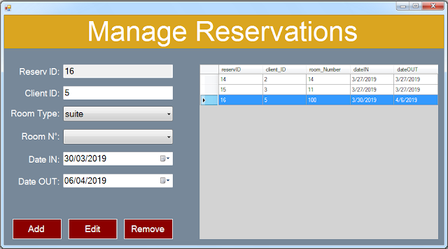

The above sample desktop system found in internet.This application is desktop application.It only work offline.

* The basic feature of this system is can easy access by an employee
* The main feature of this program is it can choose a room that suits the taste of a customer
* The rooms have three types of Single, Twice, Family and have an affordable cost.
* It have checkin/check out system.

**b. Hotel management system**

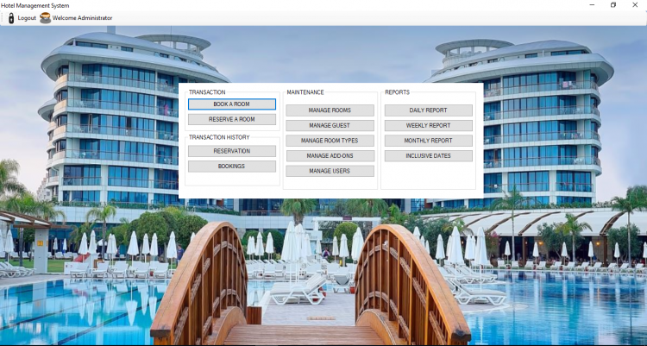

This Hotel Management System is also a desktop software based that is made of Vb.net SQL database. Their main goal of the system is to also help to manage the operations and functions to gain greater stability and more profit as well. The following are the features of the system.

* Manage Booking
* Manage Reservation
* Manage Rooms
* Manage Room Types
* Manage Guest
* Manage Add-Ons
* Manage Users

## Table of Comparison with Other System

|  |  |  |  |
| --- | --- | --- | --- |
| System Details | Hotel Management 1 | Hotel Management 2 | Home Stay Reservation |
| Login required | Yes | Yes | Yes |
| Platform | Vb.net | Vb.net | Vb.net& asp.net |
| Online | No | No | Yes |
| Devices | Laptop | Laptop | Browser and Internet |
| Operating System | Windows | Windows | No operating System |
| Features | * Easy access * Room Management * Room Records * Can add customer information | * Manage Booking * Manage Reservation * Manage Rooms * Manage Room Types * Manage Guest * Manage Add-Ons * Manage Users | * Add Staff User * Delete Staff User ’Login * Can see all Staff User ‘Login * Have all the privileges that staff can have |
| Installation | Required | Required | Not Required |
| Advantages | Have control on all sales with administrative role | Record Reservation | * Payment Calculation * Record of each Transaction * Filter Customer or any Record * Does not need any technical knowledge |

All the above three variety type of system but build in same software and for same reservation although not all for homestay but the method of reservation will serve the same. Other extra features available for billing and credit card verification.

The existing system are desktop application but Home Stay is web application by which you can manage your Home stay process in any corner of world. Does not need any laptop or device. It only required Browser and internet and you are ready to go.

# System DESIGN

## System Methodology

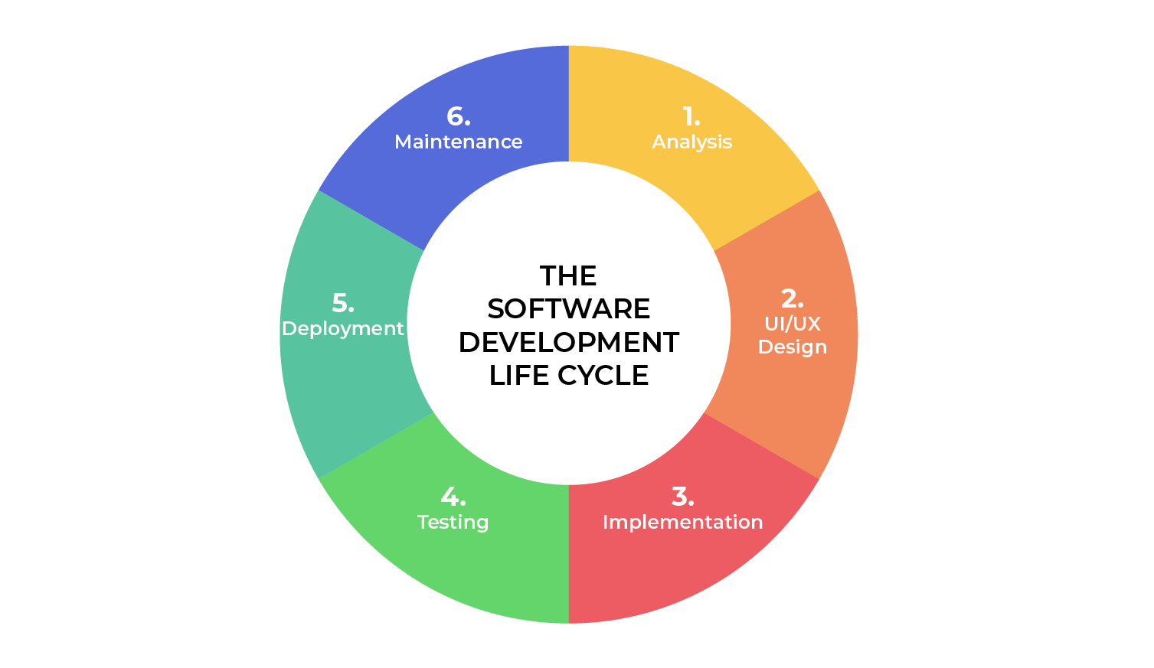

* + 1. **Software Development Process**

In the analysis phase, a software requirements collection process is carried out, such as the information domain, performance and interfaces needed. This stage will produce software requirements specifications presented in the form of data models in the form of ERD (Entity Relationship Diagram), process models in DFD (Data Flow Diagram) and transition models in the form of STD (State Transition Diagram). This application only focuses on the final results in the form of applications products.

Design is a multi-step process that follows up on the results of the analysis phase, consisting of data design in the form of database structure design, architectural design in the form of program structure design, interface design and procedural details / algorithms to be applied in the next step, making program codes.

Implementation is the process of translating designs into program codes that can be read and done by computer machines. In this case coding will be used using the Asp.net SQL database. This stage is to realize the results of analysis and design in the form of application products and this stage is presented in this documentation. Testing is the stage when the code is made consisting of internal logic testing and external functional testing to find errors and ensure results in accordance with what is needed. Tests are carried out internally by developers with results as shown in this documentation.

Different methodologies exist which is used in the development of the software process. These technologies are enlisted below

* Waterfall model
* Waterfall iterative model
* V model
* Spiral model
* Prototype model

**Waterfall Model**

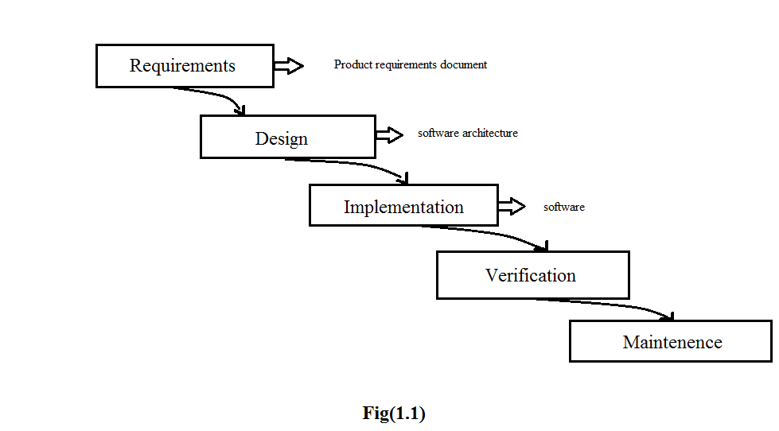

**5 phases of waterfall Model**

**Requirement Analysis and Definition**

All possible requirements of the system to be developed are started in this phase. Requirements are a set of function and constraints that the end user expects from the system.

**System and software Design**

The requirement specifications from the first phase are started here and a system design is preparing. Before starting the actual coding phase, it is highly important to understand the requirements of the end user and also have the idea of how the end product should look like.

**Implementation and Unit testing**

On receiving system design documents, the work is divided in modules and actual coding starts. The system is first elaborating into small programs called units, which are integrated in the next phase. Each unit is developed and tested or its functionality; this is referred to as unit testing.

**Integration and system testing**

The units are now integrated to form a complete system during the integration phase and tested to check if all the units are coordinating with each other, and the system as a whole behaves as per the specifications. After successfully testing the software, it is delivered to the customer.

**Operations and maintenance**

This phase of the model is virtually never-ending. Generally, problem with the system (which are note found during the development cycle) come up after its practical use starts, so the issues related to the system are solved after its development. Not all the problems come into picture directly, but they arise from time to time and need to be solved; hence this process is referred to as maintenance, even though it’s still pretty much in the testing phase.

## System Requirement

While my system functionality requirement as follows;

* Only admin have the permission to add staff user to use the system
* Manage Home Stay Bookings – Display Main Screen
* Make reservation - Customer/guest can reserve room or system maintenance- Staff user can reserve room for customer
* Delete reservation – staff can delete customer reservations
* Maintain Home/rooms

1. Add, update and delete homestay screen
2. Add, update and delete home stay room(s) screen

* Check In and Check out – Only receptionist user can check in and check out by validating customer.

## List of Facts and Assumptions

* **Experience**

1. The software developers should have a relative experience Regarding the Computer Science and collaborate with the owners so the developer take the ideas of what type of record management required. The customer must know that their information is recorded in their system. It is assumed that all the patients are familiar with tool and technology.

* **Skills**

1. Users should have basic knowledge and should be comfortable using general purpose application.
2. **Security**
3. Only authorized people will be able to access the system by entering the correct Login ID and password.

## Performance Requirements.

**a. Speed and latency requirements.**

System should response speedily as many customers book their rooms.

**b. Reliability and Availability requirements.**

System should provide very much reliability and it should not be halt in any case of burden and must be available all the time.

**c. Scalability or extensibility requirements.**

There can be a chance of enhancement so system should be scalable.

**d. Longevity requirements.**

Expected Lifetime of product according to the technologies used is 10 years.

## Software Quality attributes

The software be easily maintained and is upgraded so as to adapt to the ever-changing requirements of the company and provides additional features and functionalities. The software should be scalable. The software should be further easily upgradable so as to provide additional or new features by requiring minimum coding and adding specific or required design interface components. The software should be released with new features in different versions.

## What contribution would the project made?

It is an era of information Technology where automation of each activity is gaining importance. The app will lead to the organization and users to reserve reservations more and more effective way.

**3.6.1.** **Advantages**

* Allow easy personality test check at any time.
* Free of cost
* Not time consuming
* Increase efficiency
* Decrease labor hiring for keeping records

## Specific requirements

This section provides software requirements to a level of detail sufficient to enable designers to design the system and testers to test the system.

## Look and Feel Requirements

* + 1. **The interface**

The look of the interface is sober. The color scheme used in is simple and elegant as it is for any homestay. So, the color scheme is just as it suits to the system. All the items on the interface are visible and according to the standard colors, fonts and button etc.

* + 1. **The style Product**

We use professional approach for this and according to the standard colors, font and buttons etc.

* + 1. **Software Interface**

Any Browser and internet.

* + 1. **Hardware interface**

Screen resolution for at least 800x600 is required for proper and complete viewing of screen. Higher resolution will be accepted.

## Software Product Feature

* + 1. **Sequencing Information**

Data should be stored only in a particular sequence to avoid any inconvenience.

## Usability and Humanity Requirements.

* + 1. **Ease of use**

This system will be easy to use because its interface is easy and attractive.

* + 1. **Ease of learning**

We have already explained that the system will be friendly. We will also provide a user manual after its complete development.

* + 1. **Understandability and politeness Requirements**

The interface and everything regarding to the interface will be easy to understand. For more help, its user manual is available.

* + 1. **Design constraints**

None.

* 1. **User characteristics**
* **Educational level:** User should be comfortable with the English language
* **Experience level:** User should have previous information regarding to the computer field.
* **Skills:** user should have basic knowledge and should be should be comfortable using general purpose applications on computer and on internet online systems.
  1. **Operational Requirements.**
     1. **Expected Physical Requirements**

Product will be used in home stay or hotels reservations.

* + 1. **Expected Technological environment**

Sql server, Visual Studio (Code)

* 1. **Maintainability and support Requirements.**
     1. **Maintenance Requirements:**

The system can be maintained in present or future. It will be easy to incorporate new requirements in the individual modules.

* + 1. **Adaptability Requirements:**

Any Browser and Local Area Network.

Sql Server

* 1. **Legal Requirements**
* **Compliance Requirement**

The whole system does not violate any law or policy imposed by the Government.

* **Standard Requirements**

We will follow the standard or requirement of hotel and home stay reservation’s manual.

* **Other Requirements**

None.

* 1. **Data flow diagram**

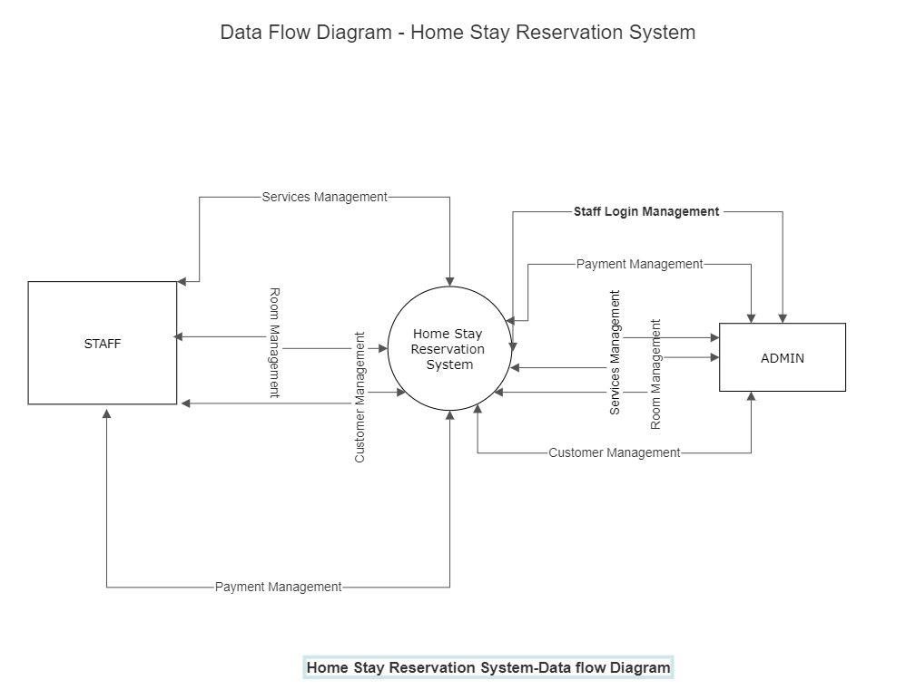

The above diagrams show data flow of the system.

* 1. **Use Case Diagram**

A use case diagram is an interaction between an information system and users of the system (Actors) that enables the users achieve a goal. A Use Case Diagram shows what activities every actor conducts in the system. The most important elements in UCD are actors and use cases.

**Basic Model Element**

**Actor:** An actor represents a role (someone) that directly interacts or uses the system.

**Association:** An association describes the relationship between an actor and a business use case in the use case diagram. Use Case: A use case is a functionality of how the system works, it describes the interaction between an actor and the system.

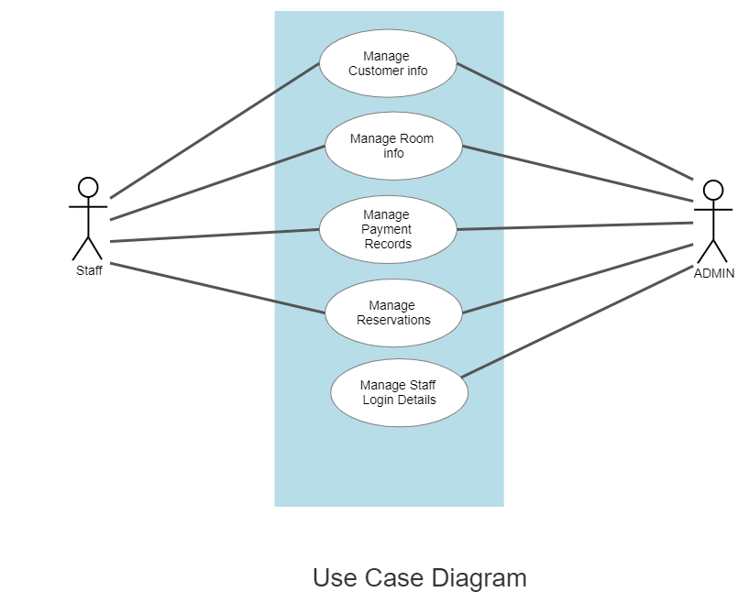

The above diagrams show the use case diagram

* 1. **Entity Relationship Diagram**

The entity Relationship Diagram (ERD) depicts the relationship between the data objects. The ERD is the notation that is used to conduct the date modeling activity the attributes of each data object noted is the ERD can be described resign a data object descriptions.

The set of primary components that are identified by the ERD are

* Data object
* Relationships
* Attributes
* Various types of indicators

The primary purpose of the ERD is to represent data objects and their relationships.

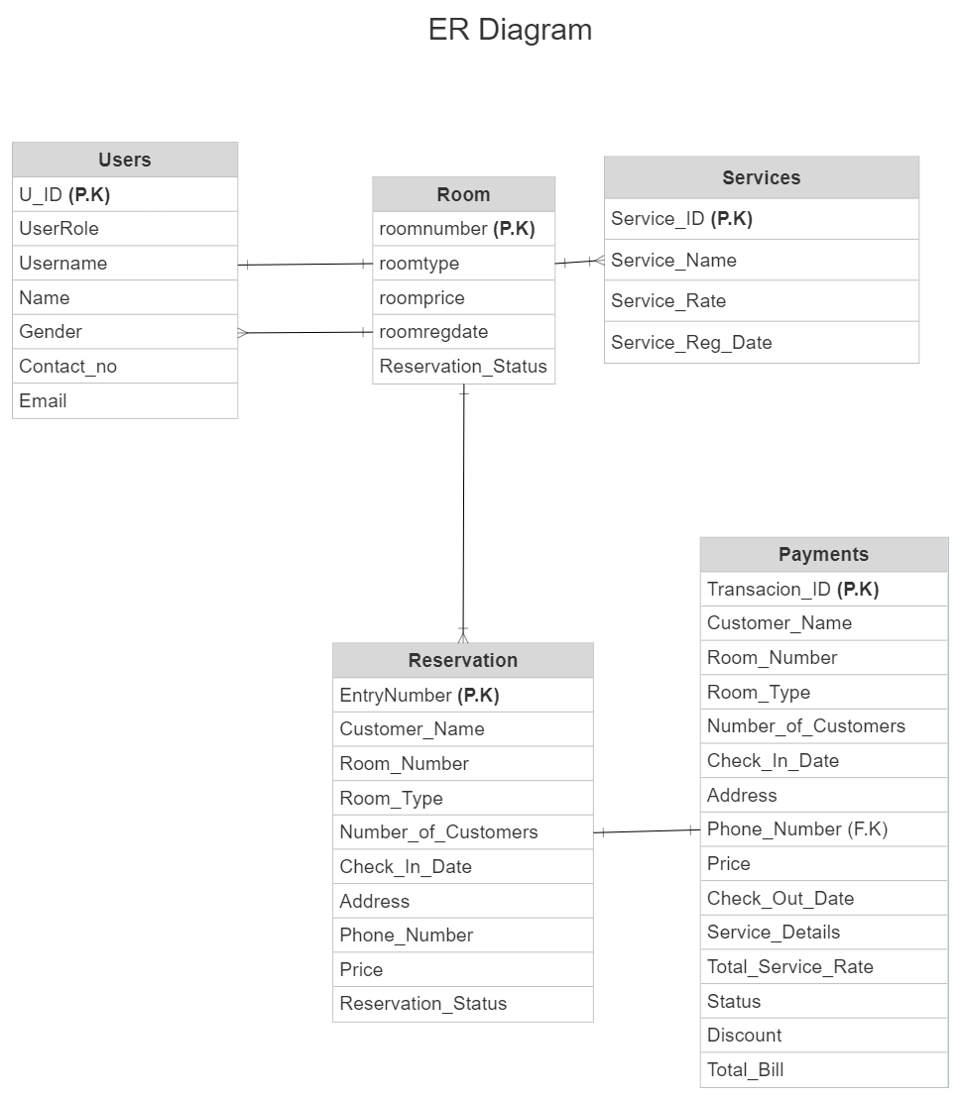

The above shows the Entity Relationship Diagram.

* 1. **Database Design**
  2. **Table:** **Users**

This table have the records of users/admin login, for saving and retrieving records.

|  |  |  |
| --- | --- | --- |
| **Fields** | **Data Type** | **Description** |
| U_ID | Int(autoincrement) | Primary key |
| UserRole | nvarchar(MAX) |  |
| Username | nvarchar(MAX) |  |
| Name | nvarchar(MAX) |  |
| Password | nvarchar(MAX) |  |
| Gender | nvarchar(MAX) |  |
| Contact_no | nvarchar(MAX) |  |
| Email | nvarchar(MAX) |  |

* 1. **Table: db_reservation**

This table have the records of reservation of customer, for saving and retrieving records of reservation of rooms and customer information.

|  |  |  |
| --- | --- | --- |
| **Fields** | **Data Type** | **Description** |
| EntryNumber | Bigint(autoincrement) | Primary key |
| Customer_Name | varchar(50) |  |
| Room_Number | varchar(50) |  |
| Room_Type | varchar(50) |  |
| Number_of_Customers | varchar(50) |  |
| Check_In_Date | date |  |
| Address | varchar(MAX) |  |
| Phone_Number | varchar(50) |  |
| Reservation_Status | varchar(50) |  |
| Price | float |  |

* 1. **Table: db_roomreg**

This table have the records rooms, for saving and retrieving records of rooms.

|  |  |  |
| --- | --- | --- |
| **Fields** | **Data Type** | **Description** |
| roomnumber | Bigint(autoincrement) | Primary key |
| roomtype | varchar(50) |  |
| roomprice | float |  |
| roomregdate | datetime |  |
| Reservation_Status | nchar(10) |  |

* 1. **Table: db_services**

This table have the records services, for saving and retrieving records of services.

|  |  |  |
| --- | --- | --- |
| **Fields** | **Data Type** | **Description** |
| Service_ID | Bigint(autoincrement) | Primary key |
| Service_Name | varchar(50) |  |
| Service_Rate | varchar(50) |  |
| Service_Reg_Date | varchar(50) |  |

* 1. **Table: db_payment**

This table is used to record the payment of checkin/checkout.

|  |  |  |
| --- | --- | --- |
| **Fields** | **Data Type** | Description |
| Transacion_ID | bigint(Autoincrement) | Primary key |
| Customer_Name | varchar(50) |  |
| Room_Number | varchar(50) |  |
| Room_Type | varchar(50) |  |
| Number_of_Customers | varchar(50) |  |
| Check_In_Date | date |  |
| Address | varchar(50) |  |
| Phone_Number | varchar(50) |  |
| Price | float |  |
| Check_Out_Date | date |  |
| Service_Details | varchar(MAX) |  |
| Total_Service_Rate | varchar(50) |  |
| Status | varchar(50) |  |
| Discount | float |  |
| Total_Bill | float |  |
| Check_Out_Date | date |  |
| Service_Details | varchar(MAX) |  |

The following are the required development Tools

* Sql Server
* Browser
* Asp.net
* Visual studio
  1. **Sample System Design – Features**

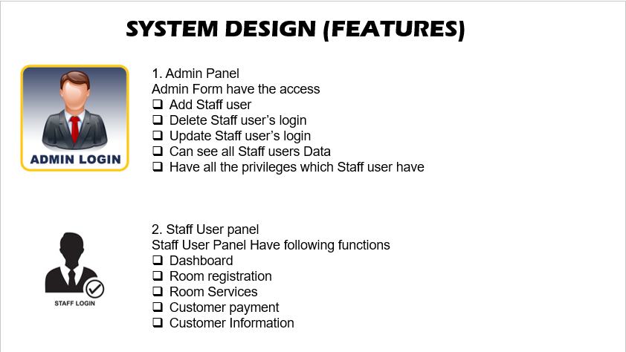

The above shows system design features for both admin panel and staff user panel.

The following are the extension points:

* Delete Reservation
* Make Reservation
* Update home stay info
* Delete home stay
* Delete room
* Update room

The below is the detailed features,

**1.Admin-Panel**

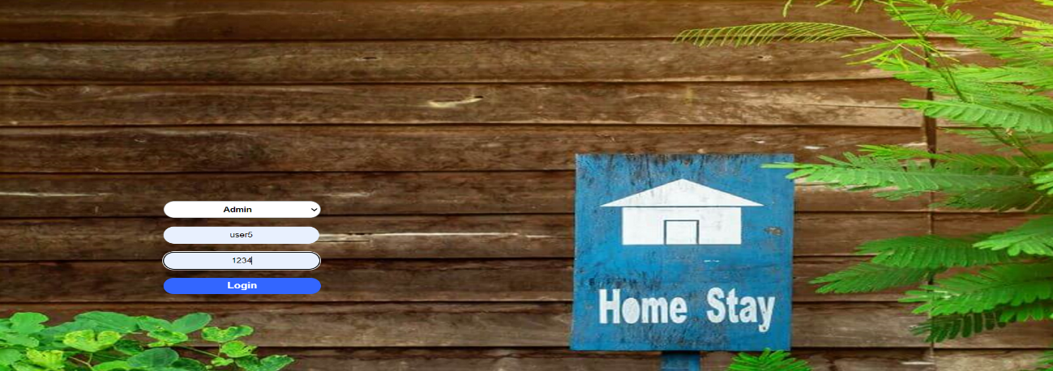

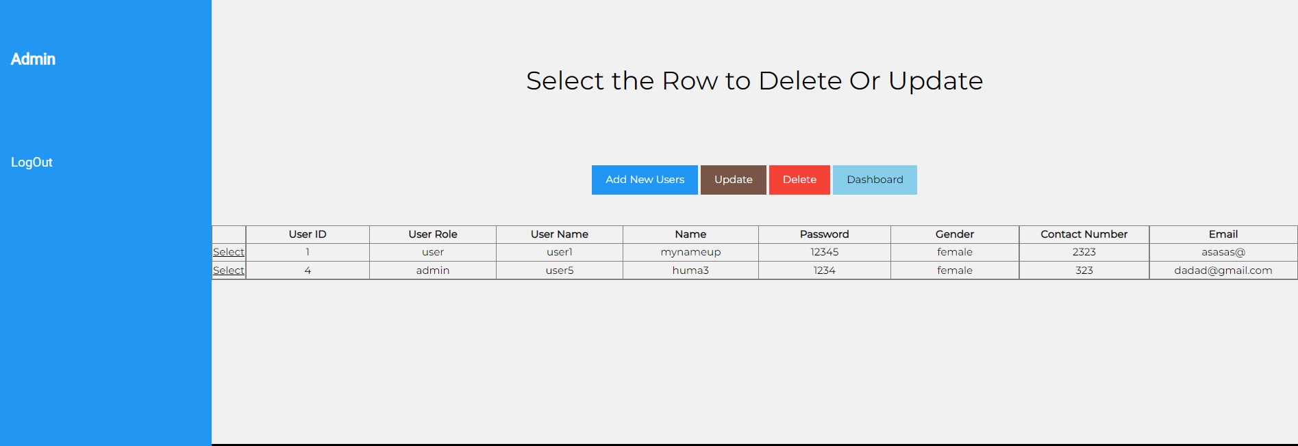

**Admin Form have the access**



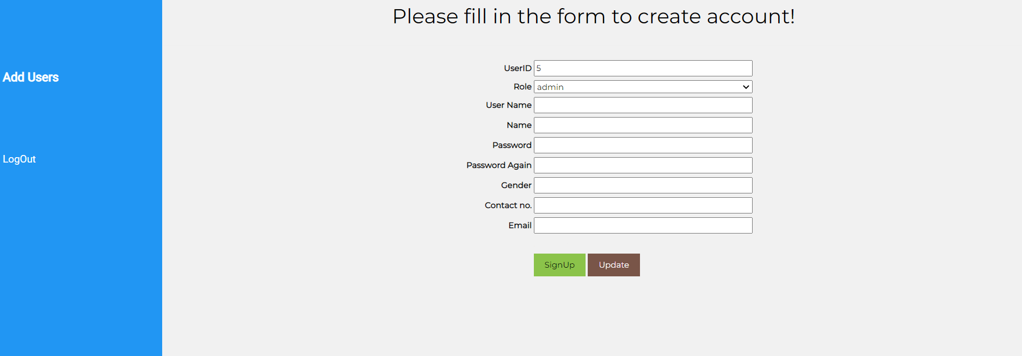

* Add Staff user
* Delete Staff user’s login
* Update Staff user’s login
* Can see all Staff users Data
* Have all the privileges which staff user have

**2.Staff-User-panel**

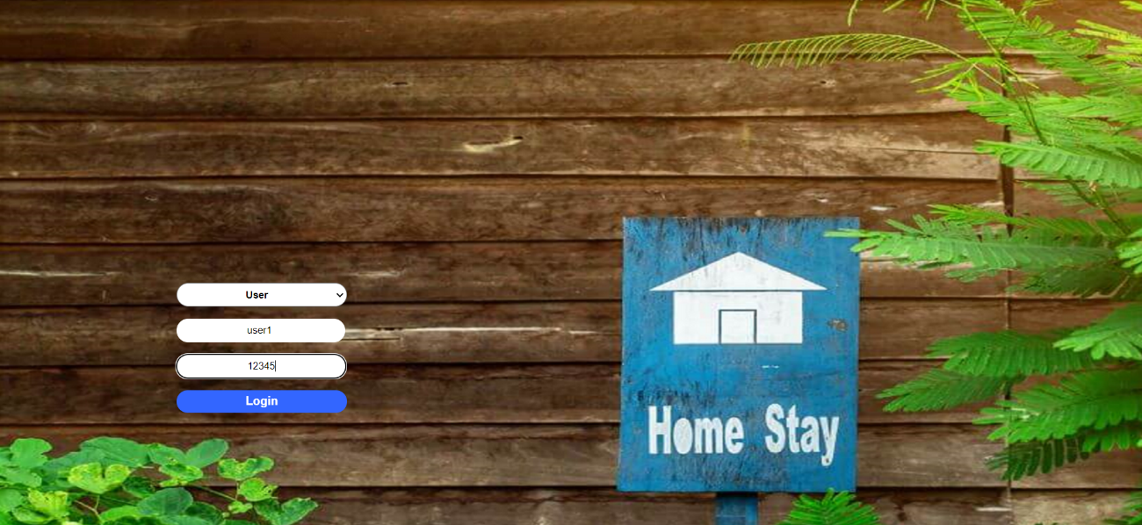

Staff User Panel Have following functions.

**2.1. Dashboard will show the total rooms.**

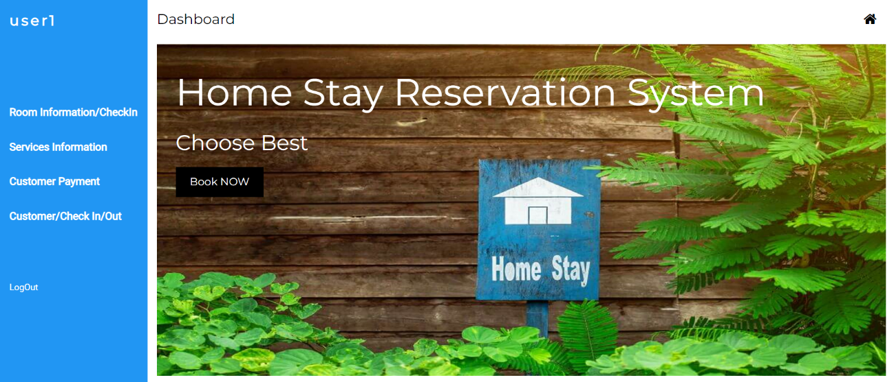

* Rooms which are reserved.
* There will be check in records of those who check in today.
* There will be a record of checkout guest.
* There is data gird which will have the list of available rooms.
* There will be a list of customers which are in home stay.

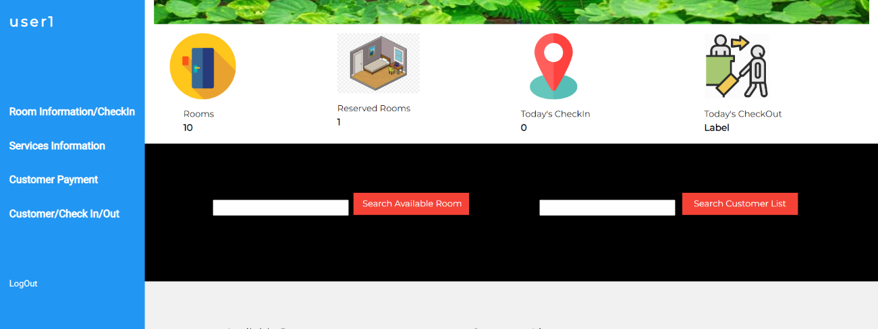

* You can search customer and available rooms from Dashboard

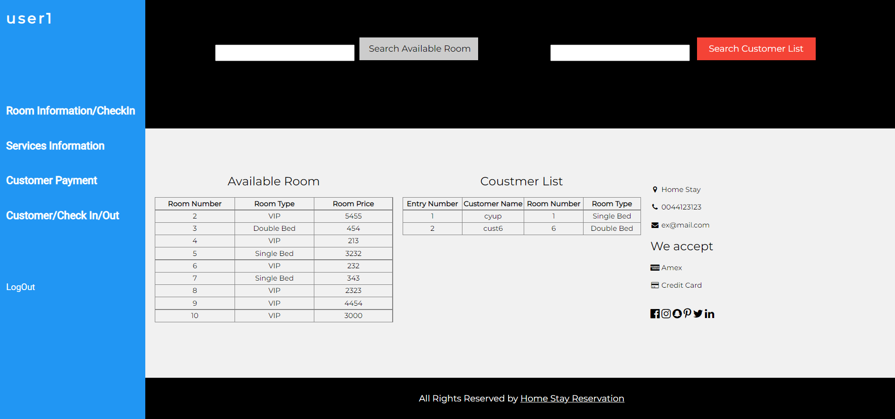

**2.2. Room registration**

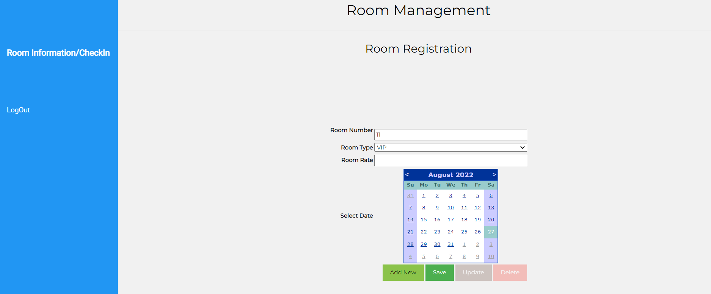

* The rooms will be registered in this module.
* There will be a grid which show the data of available rooms. The employee will select the room from list according to customer requirements.
* Check the status if the room is available or not.
* There will be a search box which help to filter the customer information who reserved the room.

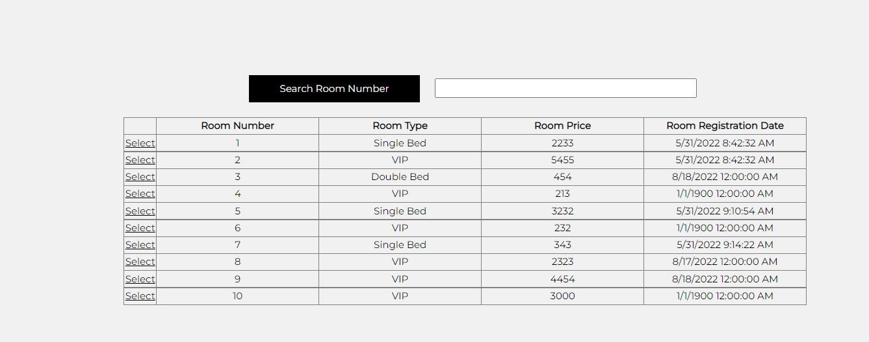

* 1. **Room service**

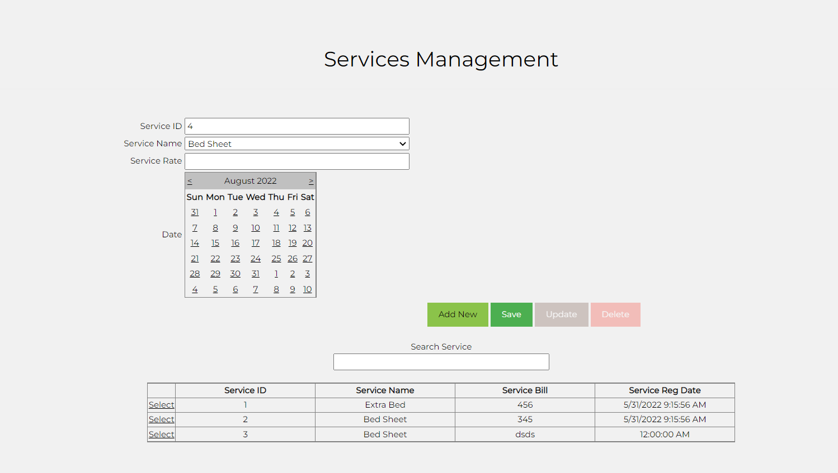

* There will be a form which is for registration of services. The services, which are used by guest will be add from available list.
* You can add, update and delete services.
* There is a record of services you can search them by textbox.
  1. **Customer payment**

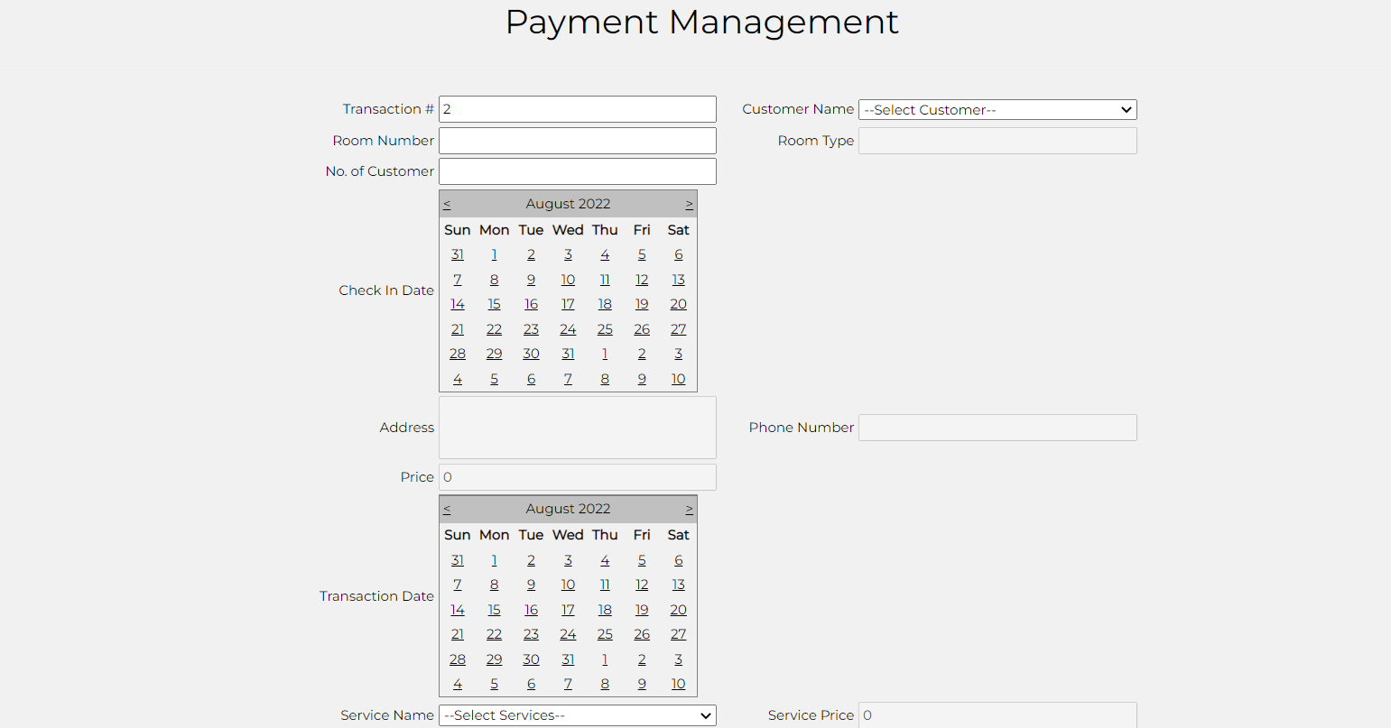

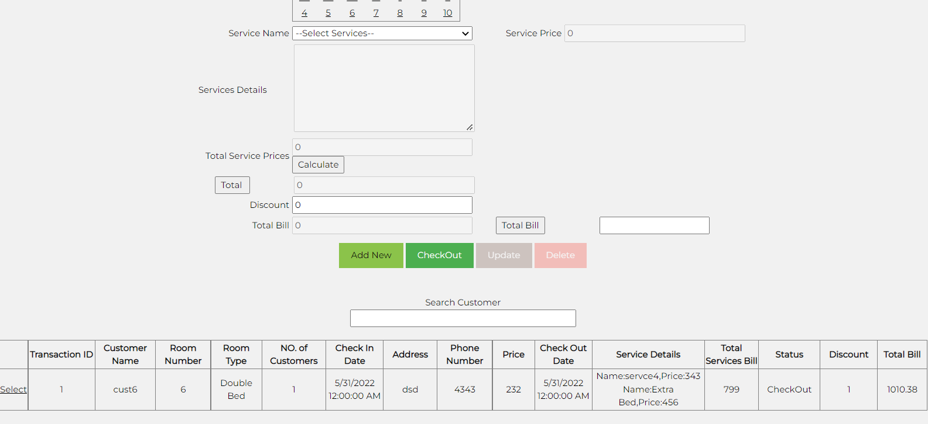

* In this form, customer data will be retrieved from database. The room charges and services charges will be added in this web form.
* There will be function of discount (if any).
* Finally, the room price, service and discount will be added and total bill will be generated.
  1. **Customer information**

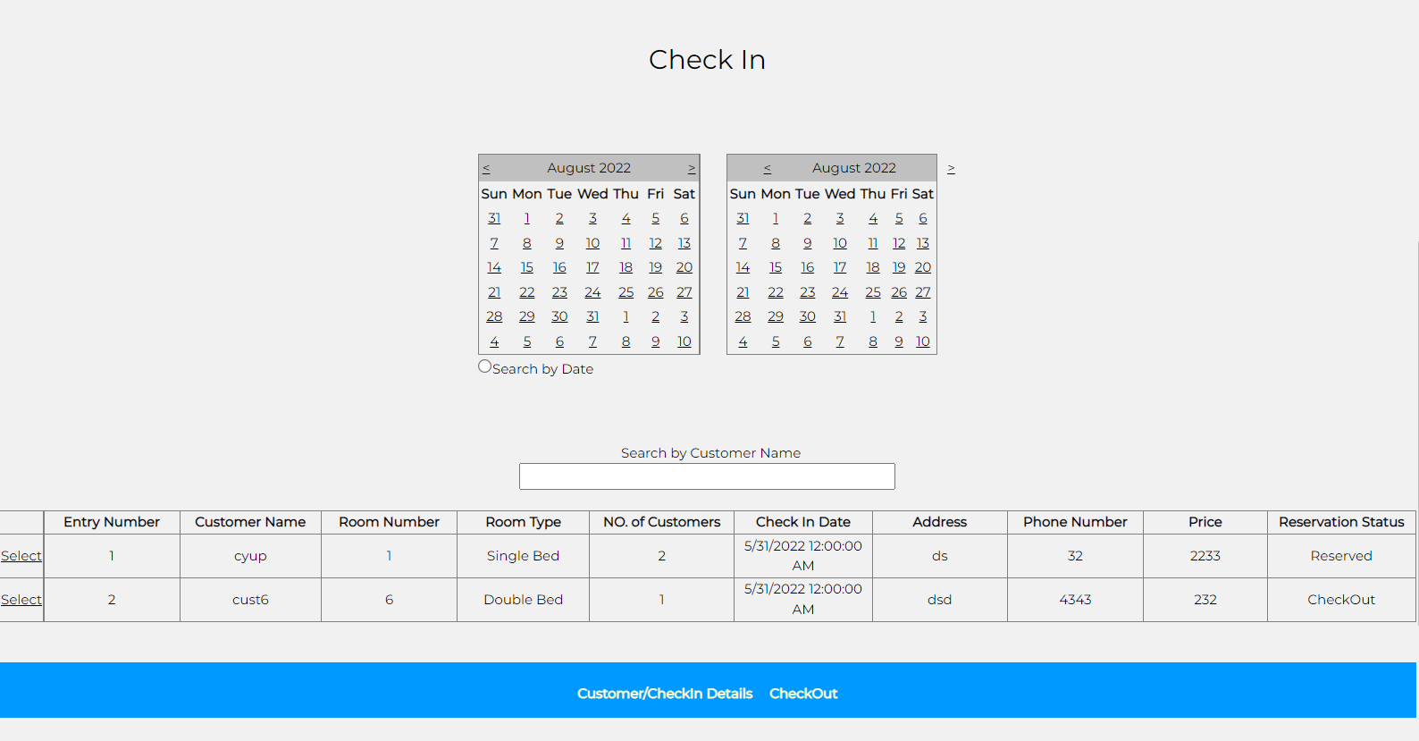

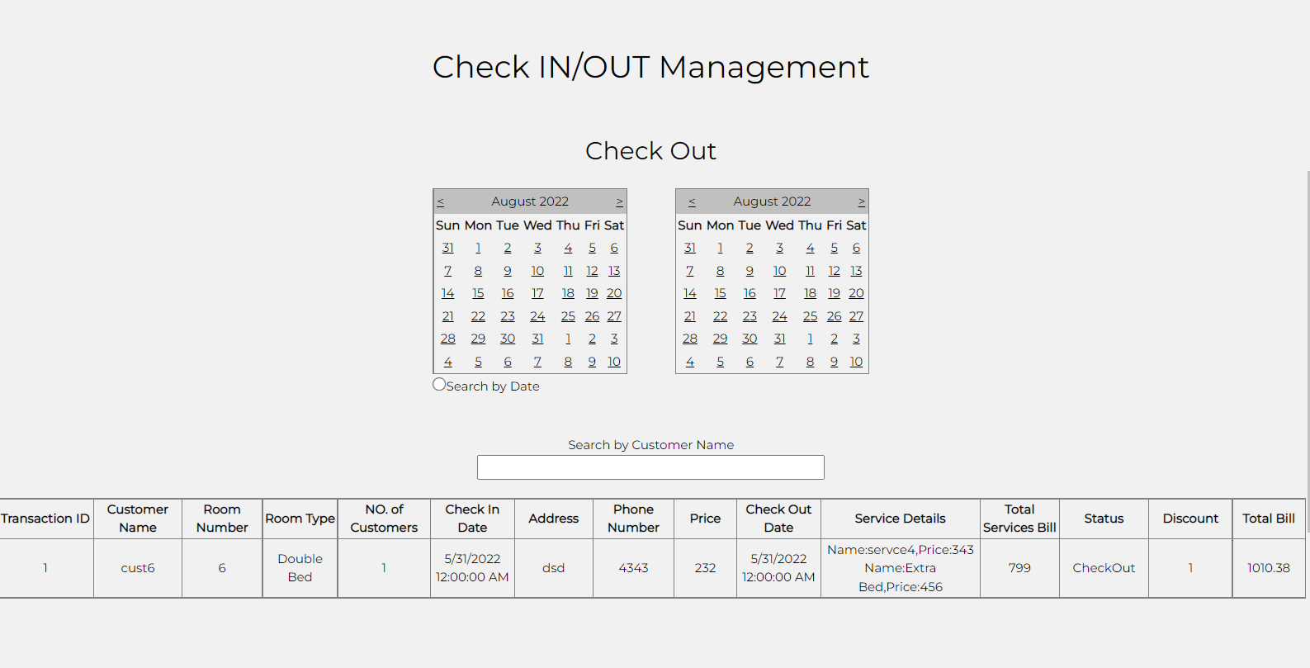

* It shows the information of all customers.
* It also will have the information of checkout/check in customers.
* There will be a filter for customer name search.
* There will be date filter to see the records.

# Deliverables and timeline

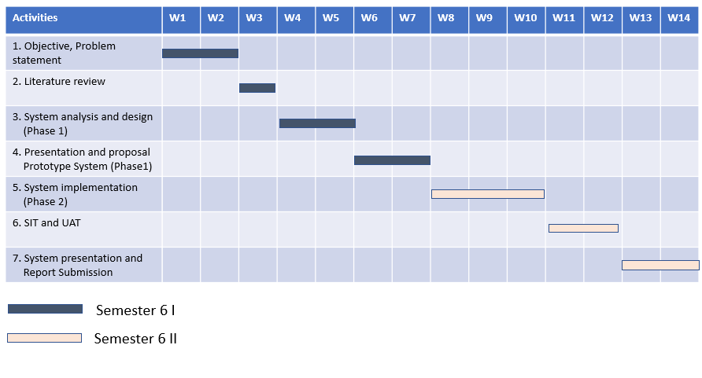

Web System development will take around 14 weeks. This is the total timeline include system requirement study until system go live.

# CONCLUSION

Home Stay Reservation System has all the dynamic versatile features required to run your hotel, or guest house business. Hotel Stay reservation System is web application that offers an operational integration between reservations, guest history, reception/ front desk, Sales Ledger. Application has facility to keep records for analyzes your booking, check in and checkout status. Home Stay Reservations system is the best suit for managing you resource in very simple but effective manner with minimal efforts or time so that it increases your revenue. This study aims to change the current system that would be accurate for both customer and Home stay management. The proponents use diagrams to implement the flow of the proposed system.

At the end, in this reservation management system it is a user-friendly for the backend admin / staff. This system will save the time and cost, and will help to manage the record or reservation properly.This will also help in growth of the company and improve knowledge in technology wise without creating any hassle

References

A. Nadamoto and K. Sakai, “Detecting and presenting welcomenews for tourists from user reviews,” International Journal of Web Information Systems, vol. 13, no. 4, pp. 354-369, 2017

N. Minić, A. Njeguš, and J. Ceballos, The Impact of Web 3.0 Technologies on Tourism Information Systems, pp. 781-787, 2014

[3] Cardoso, “E-tourism: Creating dynamic packages using semantic web processes,” W3C Workshop on Frameworks for Semantics in Web Services, 2005.

[4] P. J. Sheldon, “Destination information systems,” Annals of Tourism Research, vol. 20, no. 4, pp. 633–649, 1993.

[5] P. B. Putera, S. Laksani, and D. Prihadyanti,“Promotion optimation visit musi 2008 based on e-tourism,” in E-Indonesia Initiative 2008 (eII2008): Conference and National Meeting in Information and Communication Technology for Indonesia, 2008.

[6] C. J. Jonathan and R. E. Tarigan, “The Effects of e-tourism to the development of tourist secton in Indonesia,” CommIT (Communication & Information Technology) Journal, vol. 10, no. 2, pp. 59–62, 2016.

[7] R. Law, R. Leung & D. Buhalis, “Information technology applications in hospitality and tourism: a review of publications from 2005 to 2007,” Journal of Travel & Tourism Marketing, vol. 26, no. 5, pp. 599-623, 2009.

[8] H. Almaimoni, N. Altuwaijri, F. Asiry, S. Aldossary, M. Alsmadi, I. Al-Marashdeh, U. A. Badawi, M. Alshabanah and D. Alrajhi, “Developing and implementing web-based online destination information management system for tourism,” International Journal of Applied Engineering Research, vol. 13, no. 10, pp. 7541-7550, 2018.

[9] Jadhav, Vidyullata Shekhar and Mundhe, D. Shivaji, “Information technology in tourism,” International Journal of Computer Science and Information Technologies, (IJCSIT) vol. 2, no. 6, pp. 2822-2825, 2011.

[10] Pressman, Software Engineering, 7th Edition, McGraw-Hill International Inc, 2015.

[11] H. M. Jogiyanto, Analysis and Design of Information Systems Structured Approach Issue III, Yogyakarta: AndiOffset, 2005.

[12] A. Kadir, Introduction to Information System, Yogyakarta: Andi Offset, 2012.

[13] R. Jr. Mc.Leod, Management Information Sistem, 10th Edition, Prentice-Hall International Inc, 2015.

[14] T. Sutabri, Management Information System. Yogyakarta: Andi Offset, 2005.

[15] S. Korth, Database System Concept, 6th Edition, McGraw-Hill International Inc, 2015.

[16] Sutarman, Building Web Applications with PHP and MySQL. Publisher GrahaIlmu: Yogyakarta, 2003.

[17] E. H. William and L. David, Web Database Application with PHP and MySQL, O’Rilly and Associates Inc, 2012.

[18] B. Nugroho, Exercise Create PHP and MySQL Web Applications with Dreamweaver MX. Yogyakarta: Gava Media. 8th ed, 2008. Advances in Social Science, Education and Humanities Research, volume 354

APPENDIX

1. Login Form

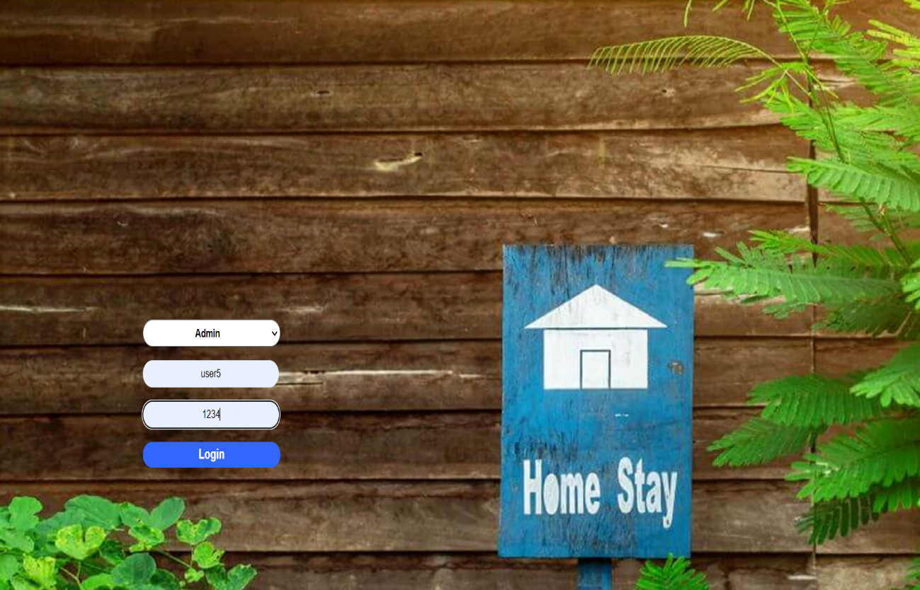

1. Sign Up Form



1. Admin Form



1. Dashboard Form







1. Room Form





1. Services Form



1. Payment Form





1. Check-in/out Form



